**ATS’s SBGI, Faculty of Engineering, Miraj.**

**Department of Computer Science and Engineering.**



**Class- S.E (CSE)**

**Batch No – S2**

**Mini Project Group No:-5**

**Mini Project Title: -**

**“KEYBOARDING”**

**Mini Project Group Members:-**

|  |  |  |  |
| --- | --- | --- | --- |
| **Roll No.** | **Name** | **Mobile** | **Email** |
| 17 | Kashinath Kallappa Mali. | 9657610259 | [kashinathmali2015@gmail.com](mailto:kashinathmali2015@gmail.com) |
| 18 | Susmit Tanaji Shrikhande. | 9423003272 | [susmit_shrikhande@yahoo.com](mailto:susmit_shrikhande@yahoo.com) |
| 19 | Shahaji Babaso Chavan. | 7219641388 | [shahajichavan0899@gmail.com](mailto:shahajichavan0899@gmail.com) |
| 20 | Rohan Dattanand  Revankar. | 7020669051 | [rohanrevankar100@gmail.com](mailto:rohanrevankar100@gmail.com) |

**Guide Name: -**Mr.C.G.Kokane.

**2017-18.**



**CERTIFICATE**

This is to certify that the following students of S.E. Computer Science &Engineering have successfully completed the project report entitled

***“KEYBOARDING”***

in the partial fulfillment of degree in the Computer Science &Engineering, of **“Shivaji University, Kolhapur”** during academic year 2017-2018.

.

Submitted By:

1) Kashinath Kallappa Mali. (2017)

2) Susmit Tanaji Shrikhande. (2018)

3) Shahaji Babaso Chavan. (2019)

4) Rohan Dattanand Revankar. (2020)

|  |  |  |  |
| --- | --- | --- | --- |
| Project Guide  Mr. C.G.Kokane. | Ext. Examiner | HOD  Mr. C.G.Kokane. | Principal  Dr. A.C.Bhagli. |

**ACKNOWLEDGEMENT**

It gives us great pleasure while presenting this project report on

**“KEYBOARDING”**

We are indeed grateful to **H.O.D.** of our Computer Science & Engg. Dept. **Prof.C.G.Kokane** for being an effective source of inspiration. A sense of prevailing satisfaction and achievement envelopes the whole feeling of having completed the project work under the guidance of **Mr.C.G.Kokane.** We wish to express our respect, deep sense of gratitude regard to him for his valuable guidance, keen interest and co-operation without which it would have been impossible to accomplish this project successfully. It was indeed great experience to work under their guidance.

Place: Miraj.

Date: /04/2018.

Students Name

1) Kashinath Kallappa Mali. (2017)

2) Susmit Tanaji Shrikhande. (2018)

3) Shahaji Babaso Chavan. (2019)

4) Rohan Dattanand Revankar. (2020)

**INDEX**

|  |  |  |
| --- | --- | --- |
| **Sr. No**. | **Content** | **Page Number** |
| 1. | Introduction  1.Abstract  2.Objective  3.Problem Definition | 5 |
| 2. | System Overview | 6 |
| 3. | System Analysis | 7 |
| 4. | Design   1. Flow Chart for input, process and output module | 8, 9 |
| 5. | Implementation | 10 |
| 6. | Measurements & Results | 11 |
| 7. | Applications | 12 |
| 8. | Conclusion | 13 |
| 9. | Future Scope | 14 |
| 10. | Snapshots | 15 |
| 11. | Appendix user Manual | 16 |
| 12 | Bibliography | 17 |

**INTRODUCTION**

**ABSTRACT**

Developing C++program to calculate the minimal no. of key strokes to type user given word using user defined keyboard. The virtual keyboard is a software or hardware components that allows user to enter characters.

**OBJECTIVE**

The problem of Keyboarding becomes complex when there are multiple same labeled keys on the keyboard to considered as one single key.

**PROBLEM DEFINITIONS**

* Layout of Virtual Keyboard.
* Entering the no. of keys in rows & columns as per layout.
* A problem arises when user type the word which has to be typed user defined keyboard layout.
* If no same labeled keys are present then problem becomes easy.

**SYSTEM OVERVIEW**

Virtual Keyboard -

Virtual keyboard is technique in which the keyboard is displayed on the screen. If the display is of touch compatible, then we can operate this keyboard using touch. If it has keys to operate the keyboard then we can operate using keys. These keys consist of arrow keys, select key etc. For an individual key of keyboard if there is one separate key is present then we can type the letter. But there is only four to five keys (arrow keys, select key etc.) are present then the no. of keystrokes are increases at typing of each letter.

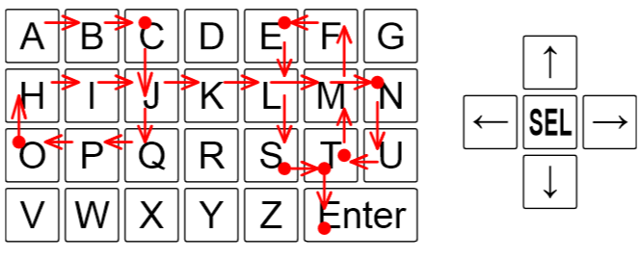

**Figure F.1: Sample Input 1. An example virtual keyboard and hardware buttons.**

Figure F.1, illustrating Sample Input 1, shows a possible way to type CONTEST using 30 strokes on an example virtual keyboard. The red dots represent the virtual keys where the select button was pressed.

**SYSTEM ANALYSIS**

In this problem we have given a virtual keyboard of any

layout provided by user. Also we have five operating keys i.e. four arrow keys and one select key. Since we have to calculate the no. of keystrokes are required to type a word which is given by the user.

**Constraints –**

* User can give any type of keyboard layout and the word which is to be type. But keyboard must be contains ‘ * ’ as the enter button,
* User cannot give the same labeled key in keyboard. If it wants to give same labeled keys then there must be link is present i.e. these keys are must be in same row or same column or both.

**FLOW CHART**

start

Enter No. of Rows & Columns (1<=r, c<=50)

END

Print count

No (n++)

If word length == length

Yes

Count++

Search ‘n’th char. On keyboard

Move Pointer on char.

Enter Keyboard layout & Word to be type.

**IMPLEMENTATION**

* **Input Module**

The first line of the input contains two integers r and c (1 ≤ r, c ≤ 50), giving

the number of rows and columns of the virtual keyboard grid. The virtual keyboard is specified in the next r lines, each of which contains c characters. The possible values of these characters are uppercase letters, digits, a dash, and an asterisk (representing Enter). There is only one key corresponding to any given character. Each key is made up of one or more grid squares, which will always form a connected region. The last line of the input contains the text to be typed. This text is a non-empty string of at most 10000 of the available characters other than the asterisk.

* **Process Module**

1. Find the first letter in the given word, in the keyboard.
2. Move the pointer on the location of required letter.
3. Press select button and count the strokes of pressed keys for an output.

* **Output Module**

Display the minimal number of strokes necessary to type the whole

text, including the Enter key at the end. It is guaranteed that the text can be typed.

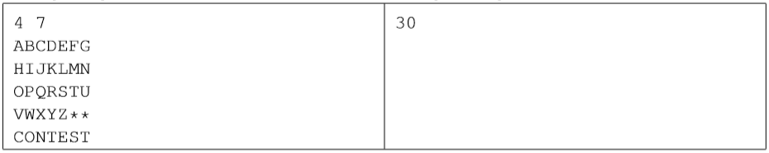



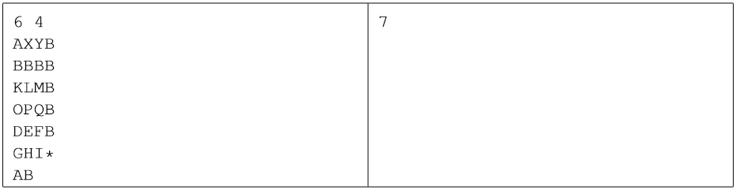

5

**MEASUREMENTS AND RESULT**

**Technical Requirements**:-

The minimum requirements:

**Hardware Requirements-**

**Computer -**

Processor- PIV with 1.90 GHz& above

Keyboard, mouse, monitor.

RAM -256MB & above

HDD -20GB & above

**Software Requirements-**

Operating System- Linux based or windows based

Software- G++ compiler.

**APPLICATIONS**

* **Breath First Search**

It is simple technique to find the position of required key by searching line by line as well as column by column.

* **Simple Shortest Path Finding Technique**

It is simple counter incrementing technique as row by row and column by column.

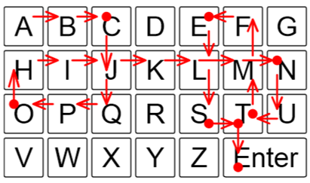

**Fig.2.**

**CONCLUSION**

By developing this program we are calculating minimum no. of keystrokes for typing the given word. Virtual keyboards claim to provide the convenience of compactness with the advantages of a full – blown QWERTY keyboard. Virtual keyboard is designed for anyone who is trying to put information into a handheld but doesn’t want carry a notebook computer around. These devices undoubtedly will replace conventional keyboards and be a groundbreaking development in the computer and IT fields. Thus virtual keyboard will make typing easier, faster & almost pleasure.

**FUTURE SCOPE**

How many key strokes are necessary to type a text message? You may think that it is equal to the number of characters in the text, but this is correct only if one keystroke generates one character. With pocket size devices, the possibilities for typing text are often limited. Some devices provide only a few buttons, signiﬁcantly fewer than the number of letters in the alphabet. For such devices, this program calculates the total no. keystrokes required to type given word.

**SNAPSHOTS**

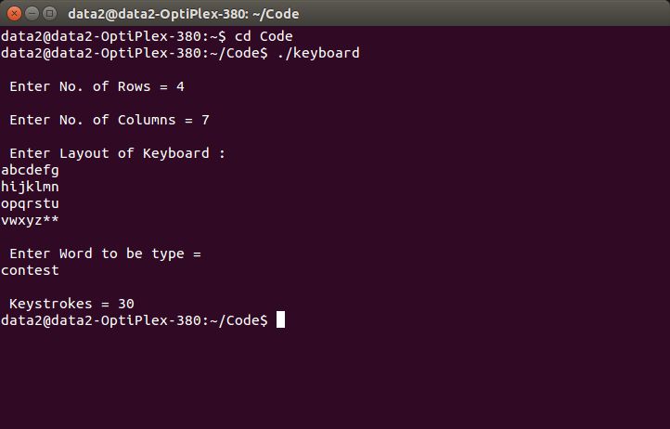

**USER MANUAL**

* User can give any type of keyboard layout and the word which is to be type. But keyboard must be contains ‘*’ as the enter button.
* User cannot give the same labeled key in keyboard. If it wants to give same labeled keys then there must be link is present i.e. these keys are must be in same row or same column or both.
* For such case there only one key is considered instead of many same labeled keys.
* The position of such key is easily founds by Breath First Search technique.
* For counting no. of keystrokes we implemented simple shortest path finding algorithm.

**BIBLIOGRAPHY**

**Website-**

[**www.acmicpc.com**](http://www.acmicpc.com/)

[**www.wikipedia.org//virtualkey10_se**](http://www.wikipedia.org//virtualkey10_se)

**Books-**

* **Let us C-Yashwant Kanetkar.**
* **Complete Reference C++ - Herbert Schildt.**